 | The CAMECA IMS 7f and 4fE7  Basic Phenomena  00 45 610 686 - Type 108 – Indice A
0000.doc
Index

Top ↑

It is well known that the impact of a primary ion (or neutral atom) possessing an energy of a few kiloelectronvolts triggers off cascades of atomic collisions, some of which end up in the ejection of one or several atoms belonging to the most superficial layers of the solid sample. The impact of the primary ion also produces electrons and photons (Fig. 1).
Figure 1.

If we now consider the cumulative effect of the whole beam of primary ions, the addition of many impacts results in the erosion of the target. Under favorable conditions ⎯ uniform beam density, lateral homogeneity of the sample and so on.., a nearly flat bottom crater is formed which deepens as the bombardment is taking place (Fig. 2).

Fig 2

Sputtered particles have a certain probability of becoming ionized as positive or negative ions during the ejection process itself. Since these sputtered ions are made from the matter of the sample, they can be used to characterize its chemical and isotopic composition; they are the secondary ion emission constituents. Secondary ions comprise single and multiple charged ions as well as clusters of several atoms. In general, but not always, the single charged ions have abundancies much higher than the others.

The existence of cluster ions has a strong impact on the design of the instrument since high mass resolution capabilities must be included in order to avoid mass interferences (Fig. 3).

Fig 3
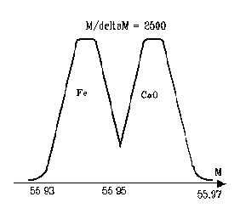

One of the most interesting features of secondary emission lies in the fact that each ion originates from a point which is in the neighborhood of the original site in the solid. This makes local analysis possible, that is, in situ sputtering of a microvolume followed by identification of the ionic species by mass spectrometry.

It is clear that the collection of secondary particles has to be done in the most efficient way but the fulfillment of that goal is hampered by the energy and angular dispersions of secondary ions (Fig. 4).
Fig 4
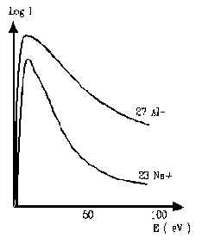

Indeed, the energy distribution has a peak at a few eV, but according to the type of ions, the distribution may be more or less narrow and its tail may spread over more than one hundred eV; besides, the directions of the ejected particle velocities are dispersed into a solid angle of nearly 2Π radians.
Top ↑

